Schedule Analysis Form
Used to record data when a digital source is not available.

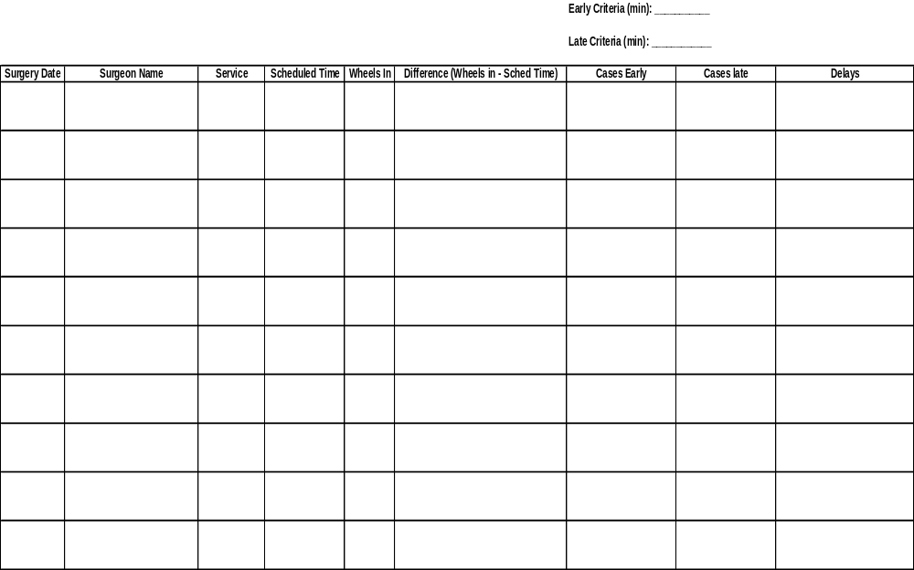
Instructions
- Enter the amount of minutes that will be the criteria for when a case can be considered an early case.
  - For example, if a negative 15 minutes is entered here, it would imply that a case must be early by more than 15 minutes in order to be counted as an early case.
- Enter the amount of minutes that will be the criteria for when a case can be considered a late case.
  - For example, if 5 minutes is entered here, it would imply that a case must be late by more than 5 minutes in order to be considered late.
- Enter the Surgery Date
  - This is suggested just in case you are gathering data for multiple dates, in order to avoid mixing up information for similar looking cases.
- Enter the name of the Surgeon performing the surgery.
  - This is for the purpose of keeping track of the Schedule Accuracy by the different surgeons in order to verify if Schedule Accuracy is substantially different between surgeons.
- Enter the name of the Service the case corresponds to.
  - This is for the purpose of keeping track of Schedule Accuracy by the different Services in order to verify if Schedule Accuracy is substantially different between services.
- Enter the Scheduled Time that belongs to that particular case.
  - It is crucial that the scheduled time be taken as it reads off of the original schedule.
- Enter the time that the patient is wheeled into the room in Real Time
  - Collecting data in Real Time is crucial in order to ensure the most accurate time.
- Calculate the difference between the Wheels In Time & the Scheduled time by taking the Wheels In Time and subtracting the Scheduled time from it.
- On the Cases Early Column, please note the cases that are early by more than the amount of minutes specified in the Early Criteria by placing the amount of time the case was early in the space required.
  - For example if the Early Criteria is -15 minutes, & if case A was early by 16 minutes, case B was early by 2 minutes, & case C was right on time:
  - In the space required on the Cases Early Column you would record 16 minutes for case A while leaving the spaces for case B & C blank.
- On the Cases Late Column, please note the cases that are late by more than the amount of minutes specified in the Late Criteria by placing the amount of time the case was late in the space required.
  - For example if the Late Criteria is 15 minutes, if case A was late by 14 minutes, case B was late by 20 minutes, & case C was right on time:
  - In the space required on the Cases Late Column you would record nothing for case A, 20 minutes for case B, while also leaving the space for case C blank.
Note: The +/- of 15 minutes that we have listed as an indication if a case is Early or Late is just a recommendations, this can be altered as you and your team see fit.
- Enter any Delay seen during the observation of On-Time Starts.
  - Examples of delays that may cause a case to be delayed Include:
    - Patient/Surgeon/Anesthesiologist Late
    - Nurse Missing or not present to set up room a short time after the previous patient was wheeled out.
    - House Keepers Missing
    - Equipment, Supplies, or Tools Missing
    - Previous case runs late
    - TOT too long
  - You can also use this as an opportunity to record any note as to why a case was early.
- Please note the example below with the 2 days of sample data
  - A sample set of performance measures are also included at the end of the example that accounts for different Schedule Analysis Calculations (for the entire data set, by Surgeon, by Service, etc.) that can be accounted for :

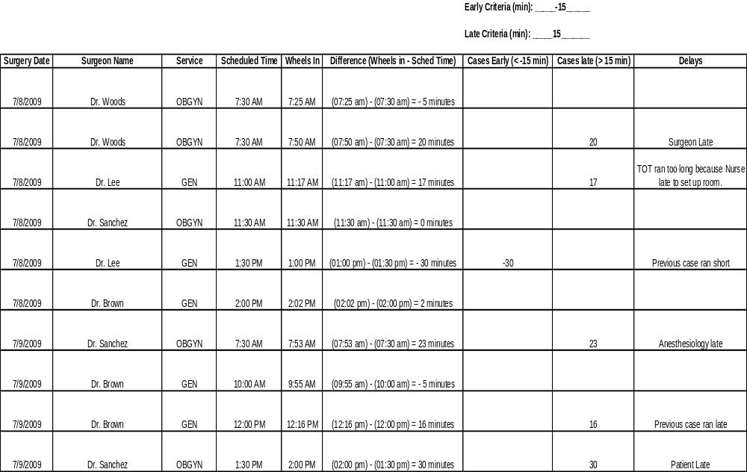
Sample Performance Measures:
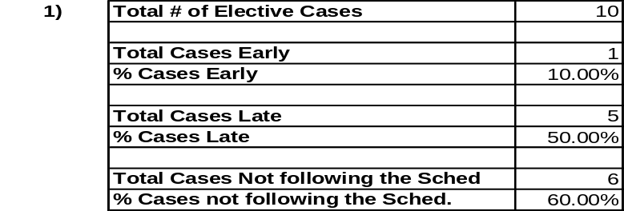
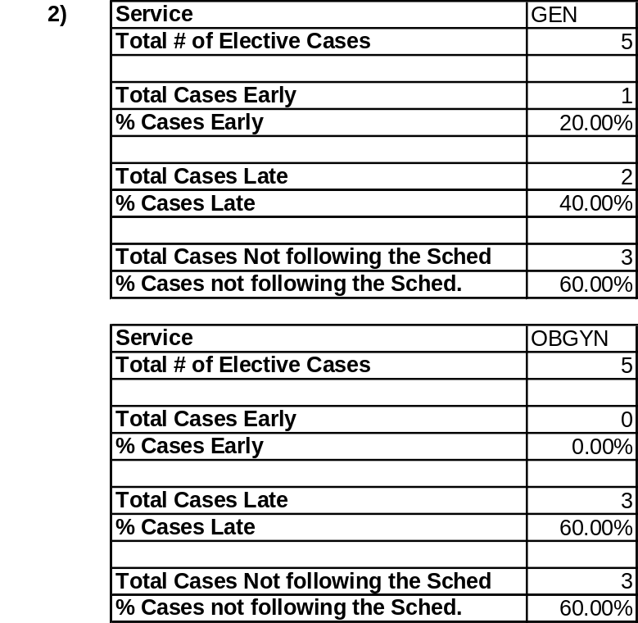

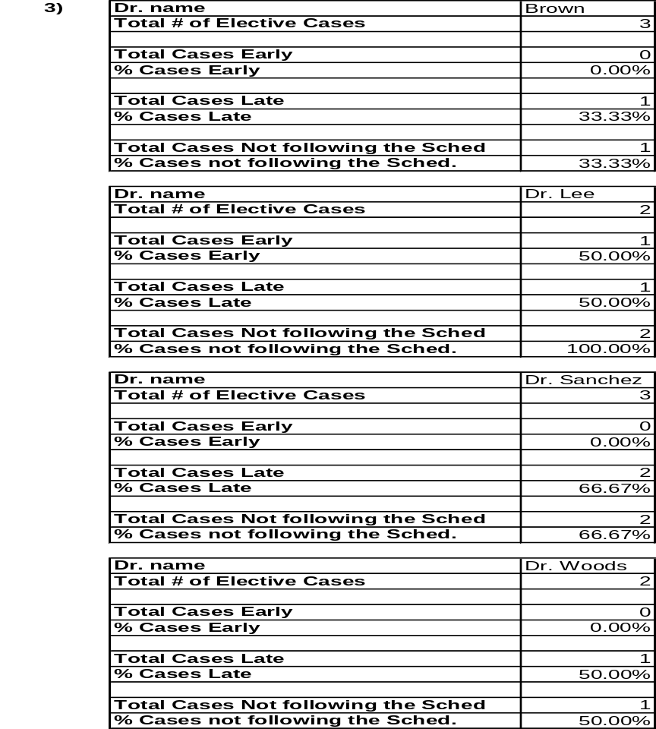

Note: As you get more days & surgeries you need to incorporate that data into your calculations.

Calculating Performance Measures:
- Calculating Schedule Accuracy for the Entire Data Set.
  - Total # of Elective Cases
    - This number would be the total number of scheduled cases for which you are tracking On-Time-Starts.
  - Total Cases Early
    - This is the total number of cases that during your study were early by more than 15 minutes.
  - % of Cases Early
    - Is the percentage of the total cases that were early by more than 15 minutes.
    - It is calculated by taking the number of cases early & dividing by the total number of elective cases.
  - Total Cases Late
    - This is the total number of cases that during your study were late by more than 15 minutes.
  - % of Cases Late
    - Is the percentage of the total cases that were late by more than 15 minutes.
    - It is calculated by taking the number of cases late & dividing by the total number of elective cases.
  - Total Cases Not Following the Schedule
    - This is the total number of cases (early & late) that do not follow the schedule.
    - This is calculated by adding up the total number of cases early plus the total number of cases late.
  - % of Cases not following the schedule
    - This is the percentage of the total cases that were early or late by more than 15 minutes.
    - It is calculated by taking the number of total cases not following the schedule and dividing it by the total number of elective cases.
- Calculating Schedule Accuracy by Service.
  - Sort the entire data set by the Service.
  - Calculate the measures described above for each particular service.
- Calculating Schedule Accuracy by Surgeon.
  - Sort the entire data set by the Surgeon.
  - Calculate the measures described above for each particular service.
- Note: Generally we tend to ignore any cases that are early less than 15 minutes.
- Note: Generally we tend to ignore any cases that are late less than 15 minutes.
  - Note: These two buffers can be altered as you see fit.
- Note: You can calculate other similar performance measures in the same manner.
  - Simply remember to collect data for the Data Title desired.
    - For example: If it is desired to calculate data by Nurse, then in your data collection process it is necessary to keep track of the nurse who will be performing surgery.
  - Additionally, remember to sort the data by the data title desired.
  - Take the different counts (Total Cases, Cases Early, Cases Late, etc.) for that particular Data Title.

